1.

**Hottest & Coldest for year 2010 :**

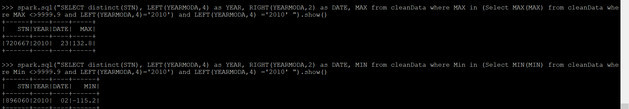

**Hottest & Coldest for year 2011 :**

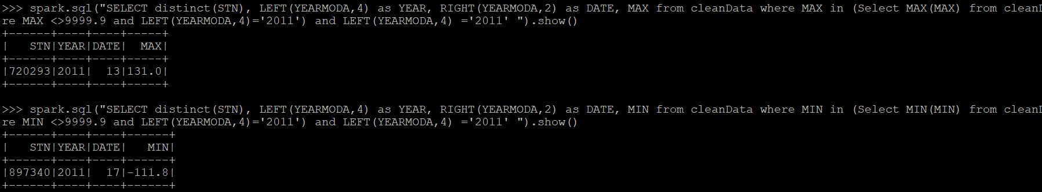

**Hottest & Coldest for year 2012 :**

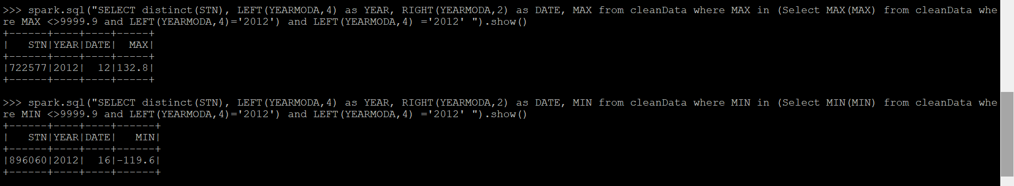

**Hottest & Coldest for year 2013 :**

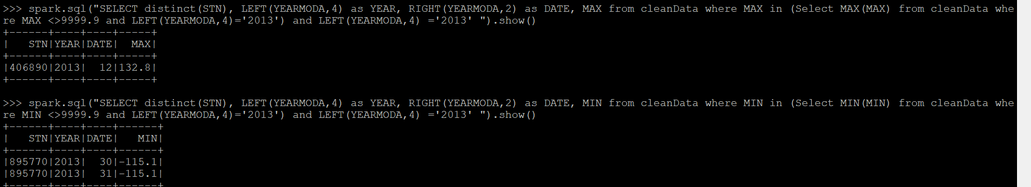

**Hottest & Coldest for year 2014 :**

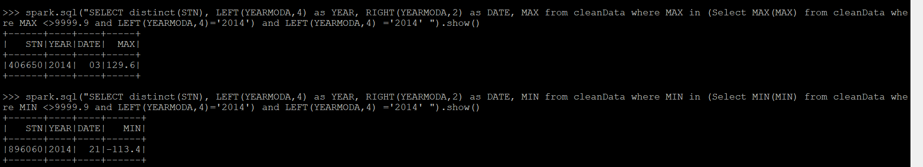

**Hottest & Coldest for year 2015 :**

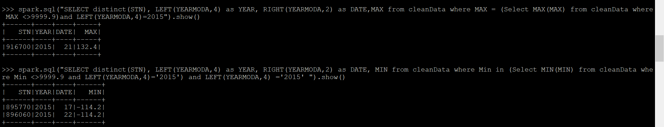

**Hottest & Coldest for year 2016 :**





**Hottest & Coldest for year 2017 :**

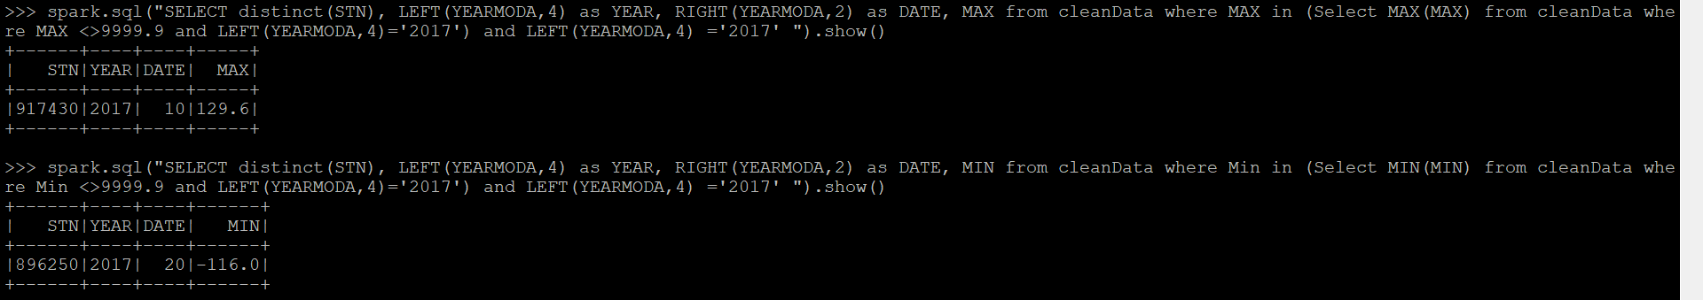

**Hottest & Coldest for year 2018 :**

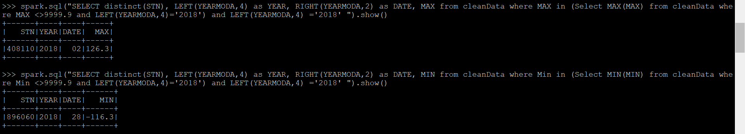

**Hottest & Coldest for year 2019 :**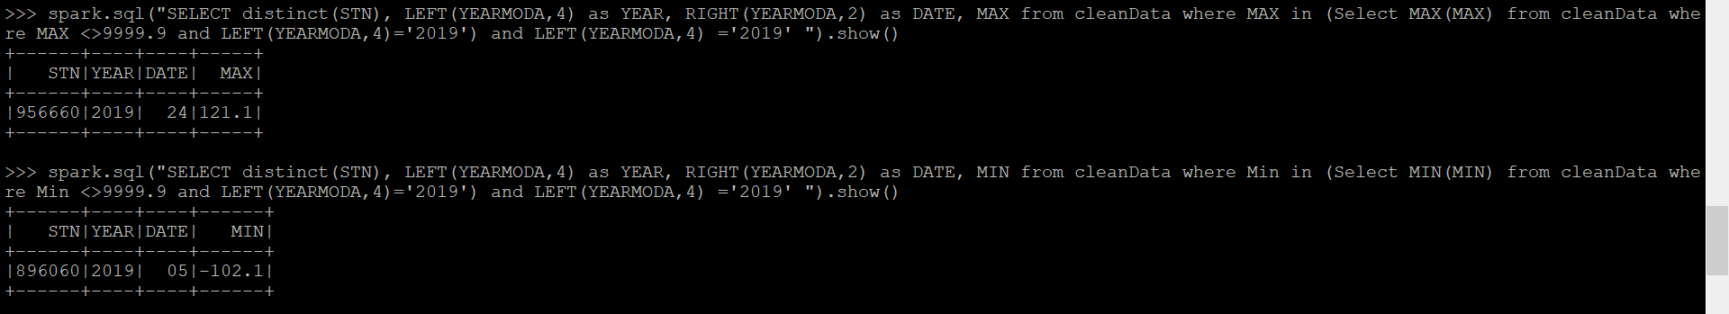

2.

**Hottest and coldest day across all years (2010 - 2019) :**

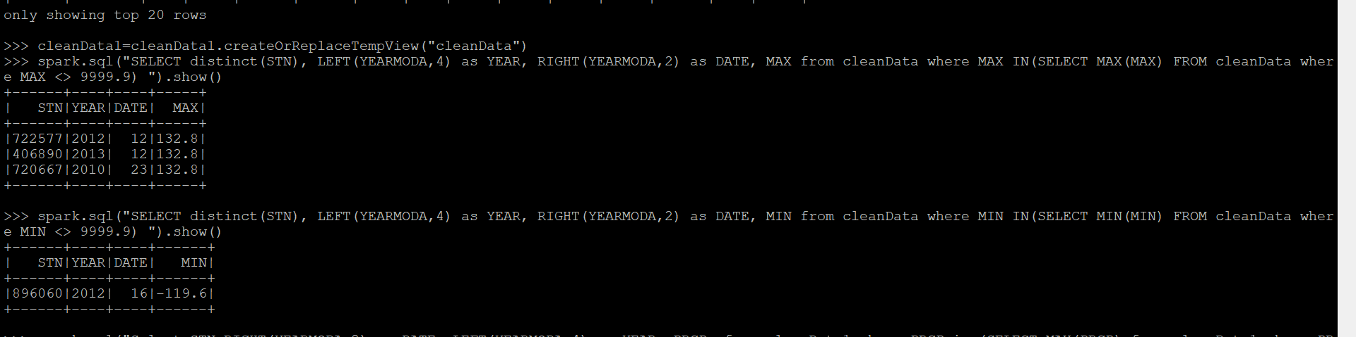

3. **Maximum and minimum precipitation for 2015 :**

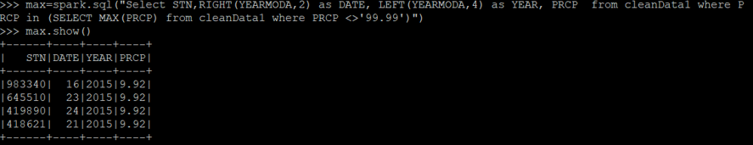

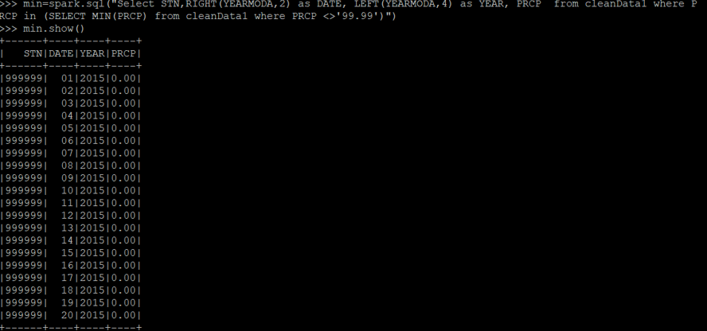

4. **Percentage missing values for mean station pressure (STP) for year 2019 :**



5. **Maximum wind gust and date for year 2019 :**

